How the Decline of Black-Owned Businesses Affects Food Access in Sistrunk: Veronica’s Story

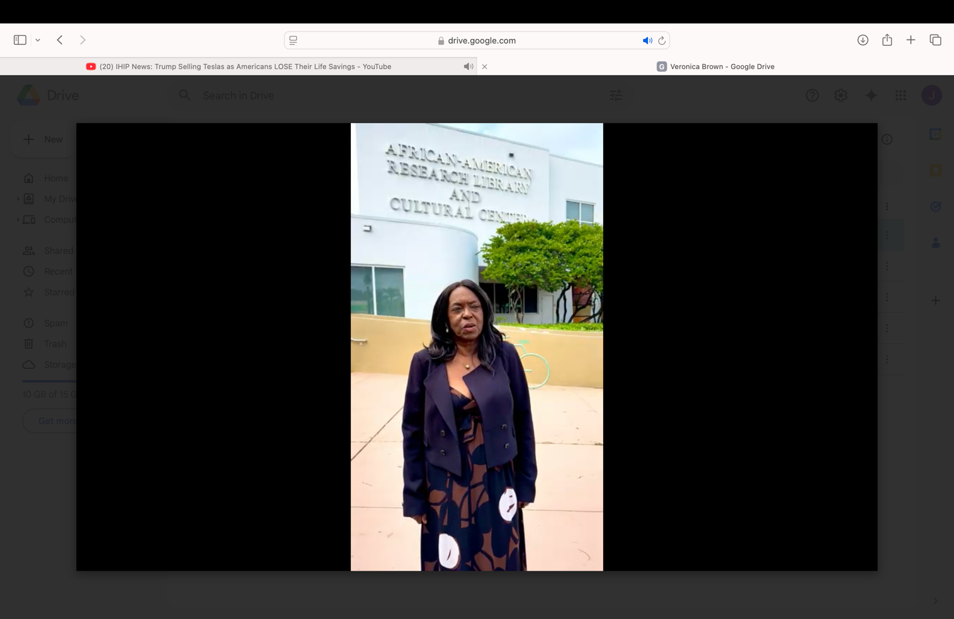
Growing up, Veronica remembers Sistrunk as a bustling marketplace, the Mecca of Black entrepreneurship. "We had everything. There was the barbershop, the hospital, a photo studio, shoe stores, the electric store, a record shop, and Zeno’s Furniture, where everybody who was anybody bought their furniture," she said, her voice tinged with nostalgia. "It was the center of Black life in Fort Lauderdale. We didn't have to leave our neighborhood for anything. Everything we needed was right here."
"When I was growing up, it was a different world. We couldn’t shop at the white-owned stores, so everything we needed was in our community, right there on 6th street, from fresh produce to meats. "But then, as things changed and segregation ended, we suddenly had more options. It was supposed to be a good thing, but it wasn’t always better.”
As the restrictions of Jim Crow faded and new stores opened, “suddenly we could shop at the white establishments, so we did. We’d go across the track… there was a new shopping mall in downtown Ft. Lauderdale with department stores, clothing, and shoe stores. So, we went there… because we COULD go there!”
She remembers when food choices were local, personal, and culturally relevant, but that all began to change as the years went on. …As she reflects on her community’s needs, Veronica ties the issue of food access to the larger changes happening in Sistrunk. “Even with the redevelopment happening now, I’m not sure how many of those businesses are Black-owned,” she said. “From what I can tell, it’s mostly outside developers. They need to make space affordable for Black entrepreneurs to return. 6th Street was ours, everything we needed was there, and it could be again if they made it work for us.”
She paused, frustrated. “When they first started talking about redevelopment, I thought they’d offer funding to help Black businesses, but that’s not happening. One guy I know was told he needed hundreds of thousands of dollars to open a business—how are Black people supposed to come up with that? It’s not realistic. The program isn’t set up for us.”
“If they really want to revitalize our community, they need to make it work for us. The businesses that used to thrive here—they were ours. If they want to help, they need to make it affordable for Black entrepreneurs to get started, that’s how we’ll make 6th Street Black again.”

