I Am Sistrunk. Says Who? Lorenzar’s story

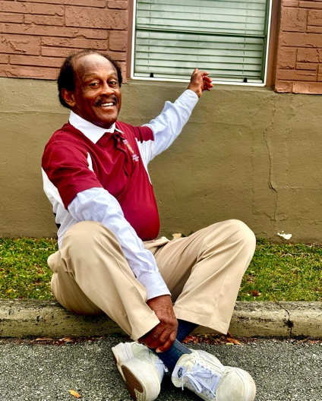
Lorenzar doesn’t waste time on pleasantries. After hello, he gets right to the point. "So where is Sistrunk anyway? And who lives there? Cuz I live in Ft. Lauderdale off Sixth Street."

“See that one?" he asks, nodding toward a vacant structure on the corner of Sixth and Seventh. "Been sitting there for over 12 years. Black folks bought it, put money into it, had plans—a hall for kids' birthday parties, space for businesses—but they ran out of funding. Now, look around. Condos. Apartments. And that building? Still just sitting there."
We cross the train tracks, the historic dividing line. "I’ll tell you about these tracks," he says. "Once you cross over, the image changes. That’s gonna be prime Sistrunk. And where do you think the rejects go? They’re pushing us west, toward the graveyard, down to 27th. That’s where the Black folks are gonna be—what’s left of us, anyway."
The shift is clear. A place that once belonged to Black residents, Black businesses, Black culture, is being carved up. The name "Sistrunk" remains, but it feels more like a marketing tool than a tribute. "That was our town," he says. "But it wasn’t no Sistrunk. Not like they call it now. It was 6th Street. And now, everybody’s either moved out, pushed out, or dead."
This isn’t the first time, he reminds me. Back in the day, they didn’t just take land—they took the water too. "You know about the beach, right?" he asks. "They ‘separated the water’, as if you can separate water. Designated part of Dania Beach for Black folks, but not the one closest to where we lived. No, they made sure we had to take a ferry to get to our designated beach. The part that was overgrown and had barely any sand. It wasn’t good enough for them, so…they felt it perfect for us."
And now? "Now that Sistrunk is desirable, it’s too good for us. They want closer access to the beach."
The same patterns play out, disguised but unchanged. "They keep you in check," he says. "You can only go so far, only get so much money. If they control your resources, you can’t operate. If you don’t have the job, you can’t pay the rent. And that’s not by accident." He pauses for a moment. "We haven’t been fed the nutrients our community needs to keep growing.”

