The Illusion of Progress: David’s Story

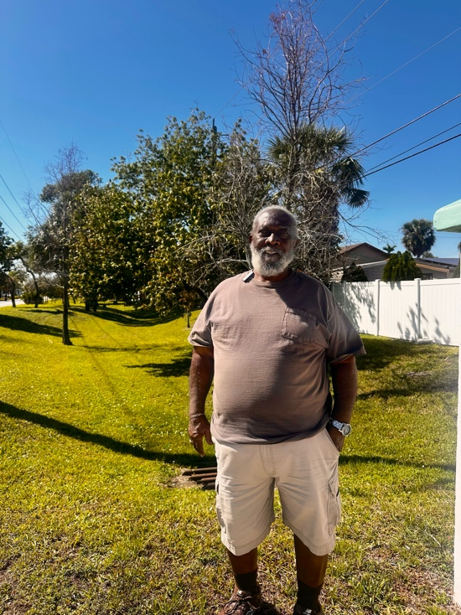
David has lived in Broward County long enough to know that progress depends on who is telling the story. Once Sistrunk was a thriving Black community—a place where families could build, own, and pass something down. "We had our businesses, our homes. Now we’re just the front for the new businesses here. We work in them but we don’t own them."
David is no stranger to how things work. He is one of the few who had managed to hold onto his home while others around him were forced to sell. He has seen the city’s tactics up close, the way town hall meetings about development are held in the middle of the workday, the way entire neighborhoods have been torn down with little more than a whisper of warning. “They do what they wanna do. By the time we find out, it’s already decided.”

He took me to the corner of Sistrunk Road and NW 29th Terrace to see the ditch. To me, it was just an open stretch of land, palm trees, grass. But David knew that it was where an entire neighborhood once stood, a community of Black homeowners. “They paid folks off. Told ‘em they had to sell, or they’d take it from ‘em because they were holding up progress. Then they just left it like this.” He gestured to the empty space, shaking his head. It was supposed to become something—maybe a park, maybe a commercial hub—but instead, it was nothing. A scar in the middle of the neighborhood. Those who had been here long enough saw it for what it was. Newcomers like me would only see pretty grass and palm trees, blind to what had been displaced. When land becomes valuable, people and history doesn’t stand a chance. “They take things down and put up condos. And who do you think can afford those?” He asked, giving me a knowing look. "At the rate they’re going, every old building is coming down. Replaced with condos, built as high as they can. And Black folks? We won’t be able to afford any of it."

“They call it progress,” he said, shaking his head, “but whose progress, not ours!” We stood in front of the ditch, a silent marker of what was lost. David let out a slow exhale, then looked at me. "They don’t call it what it is, but I see it, clear as day.”

