From Scarcity to Strength: Fort Lauderdale City Commissioner Pamela Beasley-Pittman’s Bold Vision for Sistrunk’s Future

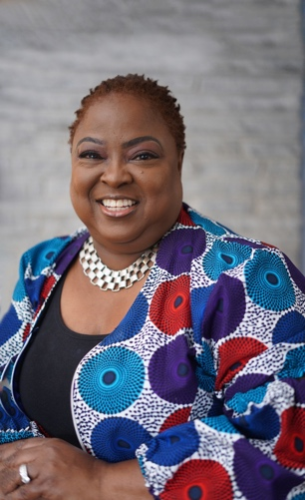
” This isn’t just a food desert—it’s food apartheid. Deserts form naturally. This? This is by design. Grocery stores didn’t just disappear. They were never invested in. Small markets struggle to carry fresh food because suppliers charge them more, and big chains won’t set up shop unless the profits are guaranteed. Meanwhile, the communities most affected are left with what’s cheap, processed, and convenient.”
Systemic change doesn’t come from another handout—it comes from ownership, access, and power. A pop-up food truck can feed people for a day. A Mobile Food Bus can provide fresh produce for a week. But neither will fix a system designed to keep communities dependent instead of empowered.
Real transformation happens when we stop accepting scraps and start demanding investment. When we move from scarcity to control. From just surviving to building something that lasts. That’s how we build a future where food security isn’t a privilege—it’s a given.
And five years from now, Beasley-Pittman doesn’t just see better food options in one neighborhood. She sees homeowners instead of renters. Entrepreneurs instead of employees. Communities that demand more—and get it.
Because a community that owns its resources, owns its destiny—and Beasley-Pittman is making sure her district claims what’s rightfully theirs.

