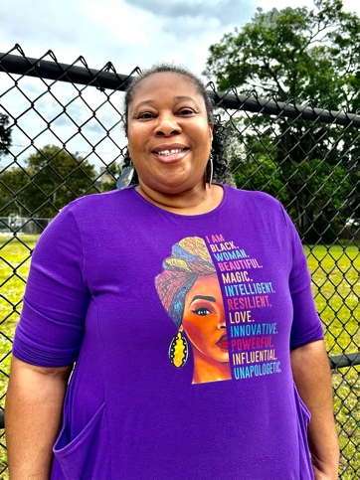
What Was Lost and What Remains: Aretha’s Sistrunk
Hearing about a neighborhood’s decline is one thing. Seeing it, block by block, through the eyes of someone who loves it—that’s something else entirely. First stop—Tater Town. Or at least, what’s left of it.
Aretha steps out, eyes fixed on another vacant lot. But in her memory, it’s alive.

"Imagine this," she says, sweeping her arm. “Rows of vendor tables piled high—peaches, ripe tomatoes, okra (green ones, too, for the old-school folks). Sweet potatoes, blue peanuts, fresh squash. Neighbors laughing, catching up. You didn’t just shop here—you reconnected with family, old friends, people you hadn’t seen in years”.

And it wasn’t just about feeding the community—”it was a lifeline for the farmers who supplied it… Tater Town was more than a market," Aretha says. "It was a distribution system for small, minority farmers. They didn’t need contracts with Winn-Dixie—Tater Town was their market. When it closed, their income dried up. We don’t even know what happened to some of them." Now, it’s just another vacant lot. The city keeps delaying, but everyone knows—development is coming, not a market. "They’ll pave over it," she says. "And just like that, it’ll be gone." But for her, Tater Town still stands. And for a brief moment, I see it too.
…In her mind, it’s still alive—the tables overflowing with fresh produce, neighbors greeting each other, a place where community wasn’t just preserved but strengthened.
Because for Aretha, the fight isn’t just about food.
It’s about dignity.
It’s about belonging.
It’s about making sure Sistrunk’s history isn’t erased to make way for something unrecognizable. Because the loss of a grocery store is never just about groceries.
It’s about a community.
And once it’s gone, it’s almost impossible to get back.

